7th Grade Spring Break Review Packet
Name _______________________________
Order of Operations
- 17 – 6 ∙ 10 ÷ 2 + 12
Adding Integers
- 172 + (–167) + (–10) + (–144)
Subtracting Integers
- 6 – (–9)
Multiplying and Dividing Integers
- 4(–7)
- –88 ÷ 11
- –95 ÷ −5
Adding and Subtracting Rational Numbers
- $\frac{4}{12}+ \frac{9}{12}$
- $\frac{2}{3}+\frac{1}{11}$
- $-\frac{17}{9}-\frac{14}{8}$
- $13\frac{1}{3}- 7\frac{7}{9}$
Multiplying Rational Numbers
- $\frac{-4}{7}×\frac{-3}{4}$
- $A garden is 14\frac{1}{2} ft by 13\frac{1}{4}ft. What is the area of the garden?$
Dividing Rational Numbers
- $\frac{2}{9}÷\frac{-3}{27}$
Solving One-Step Equations
- y + (–6) = –9
Solving Two-Step Equations
- –6 + 3x = –9
- $\frac{x}{5}+ 9=4$

Solving Multi-Step Equations
- 5m + 4m = 72
- 78 = -2(m + 3) + m
- x + 7 = 6x – 3
- Suppose you have 30 CDs. You know that you have 11 more CDs than your friend. Write and solve an equation to find the number of CDs your friend has.
Solving One-Step Inequalities
- -a + 4 ≥ 8
- q – 7 > 0
- $\frac{h}{2} -25$
- Mark wants to buy a video game system for $270. He has $60 and is saving $30 each week. Solve the equation 30w + 60 = 270 to find how many weeks w it will take Mark to save enough to buy the system
Solving Two-Step Inequalities
- 3 m+9 ≤ 49.
- − 2 x – 10 > - 14
- -x – 4x < 0
Graphing on the Coordinate Plane
- Graph and label each ordered pair on the coordinate plane below
  - A (4, 6)
  - B (-5, 7)
  - C (-9, -5)
  - D (0, -4)
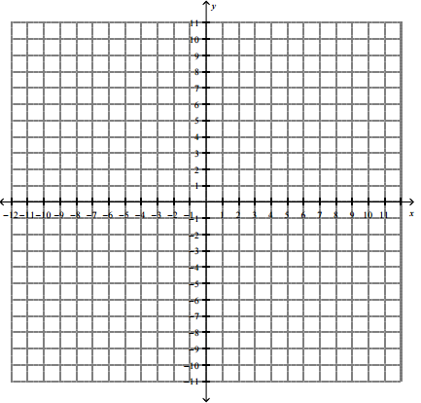
Measures of Central Tendency
23, 29, 24, 19, 27, 16, 28, 20, 20, 21, 25
- mean:
- median:
- mode:
- range:

Proportions: Solve for the unknown variable.
- $\frac{x}{5}=\frac{15}{25}$
- $\frac{x+3}{2}=\frac{5}{4}$
- If it takes 8 furniture delivery trucks to cover 72 square miles, how many trucks are needed to cover 136 square miles? Write and solve a proportion.
Unit Rates
- 48 gallons in 12 minutes

- 400 meters in 22 seconds

