Math HW # 18 - 12/19/14 Name _____________________________________
1. Guests at a pizza party are seated at three tables. The small table has 5 seats and 2 pizzas. The medium table has 7 seats and 3 pizzas. The large table has 12 seats and 5 pizzas. The pizzas at each table are shared equally. At which table does a guest get the most pizza?

2. Supposed a news story about the Super Bowl claims "men outnumbered women in the stadium by a ratio of 9 to 5." Haru thinks that means there were 14 people in the stadium -- 9 men and 5 women. Do you agree with Haru? Why or why not?

3. The two histograms below display information about gallons of water used per person in 24 households in a week.
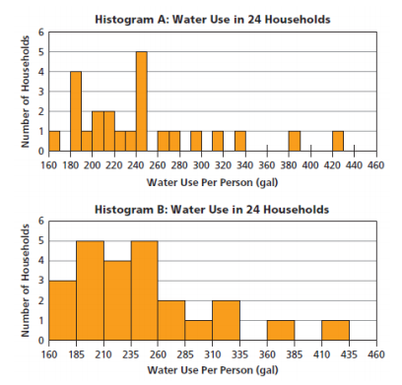
a. Compare the two histograms and explain how they differ.

b. Where do the data seem to clump in Histograms A and B?

