Name ____________________________________ HW #19 10/9/14 Class __________
1.) Replace n with a number to make each statement true.
a.) n + ¯18 = 8 n =________
b.) ¯24 - n = 12 n = _______
c.) 43 + n = ¯12 n =________
d.) ¯20 - n = ¯50 n =________
2.) Starting from 0, write an addition sentence for the diagrams below. Answer on the line provided.
Example:
The number line below represents: 0 - 2 + 3 = 1
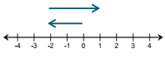
a.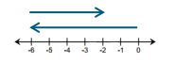____________ b. 

