Name:_______________________ Science Take Home Test
Class: _______________________ Chapter 6 & 7

- What is the name of the ancient supercontinent shown below?

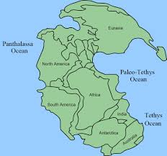

A. Hogwarts
B. Pangaea
C. Land Before Time
D. Laurasia

2. Which term refers to sections of Earth’s crust and part of the upper mantel?

A. Asthenosphere
B. Plate
C. Lithosphere
D. Core

3. Where do Earth’s plates slide past each other?

A. Convergent boundaries
B. Divergent boundaries
C. Transform boundaries
D. Subduction Zone

4. Which statement best explains why the Mesosaurus fossils are found today in some layers in both South America and Africa?
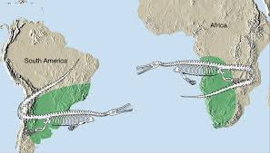

- Mesosaurus swam across the ocean between the continents
- The continents were once connected as a single landmass
- Global warming had been raising the sea level in the Atlantic Ocean
- The remains of Mesosaurus were carried across the ocean by producers

5. What type of lava flows easily?
A. Silica-rich
B. Composite
C. Basaltic
D. Smooth

6. Which seismic wave moves through Earth at the fastest speed?
A. Primary wave
B. Secondary wave
C. Surface wave
D. Tsunami

7. What is the point (B) on Earth’s surface directly above an earthquake’s focus (A)?

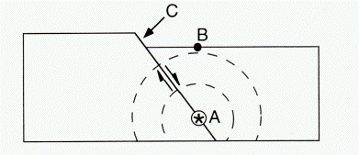

A. Earthquake center
B. Epicenter
C. Fault
D. Focus

8. What evidence in rocks supports the theory of seafloor spreading?

A. Plate Movement
B. Magnetic Reversals
C. Subduction
D. Convergence

9. What hypothesis states that continents slowly moved to their present positions on Earth?

A. Subduction
B. Erosion
C. Continental drift
D. Newton’s law

10. Which layer of Earth contains the asthenosphere?

A. Crust
B. Mantle
C. Outer Core
D. Inner Core

11. Most of Earth’s major earthquakes are caused by

A. Seasonal heating and cooling of Earth’s surface
B. Weathering of rock at Earth’s surface
C. Earth’s gravitational attraction to the moon
D. Faulting of rock in Earth’s crust

12. The surface of earth is covered mostly by

A. Solid rock
B. Ice
C. Molten rock
D. Water

13. What information did scientists study in order to develop this model?

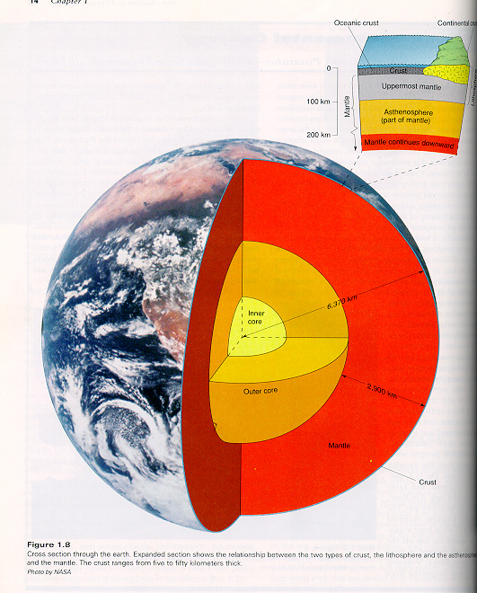

- Core samples from Seafloor spreading
- Fossils found in rocks
- Locations of recent volcanic activity
- Recordings of earthquake waves

Choose the best answer to label the parts of the Earth (14-17 on next page).

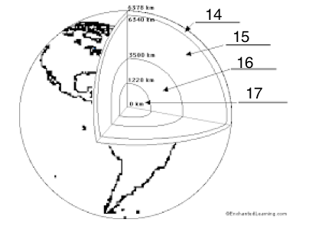

14 ____________

A. Inner Core
B. Mid-Ocean ridge
C. Magma
D. Crust

15 ____________

A. Mid-Ocean Ridge
B. Outer Core
C. Mantel
D. Crust

16 ____________

A. Outer Core
B. Seafloor Spreading
C. Molten Rock
D. Magma

17 ______________

A. Mid-Ocean Ridge
B. Inner Core
C. Mantel
D. Rift Valley

18. What is molten rock called?

A. Magma
B. Limestone
C. Sediment
D. Ash

(19 and 20 on next page)
19. What was the theory Alfred Wegener hypothesized? List two pieces of evidence
Wegener found, and explain how they support his theory.

_________________________________________________________________________________________________

_________________________________________________________________________________________________

_________________________________________________________________________________________________

_________________________________________________________________________________________________

_________________________________________________________________________________________________

_________________________________________________________________________________________________

_________________________________________________________________________________________________

20. Describe the seismograph and Richter scale. Explain why they are useful in measuring earthquakes.

_________________________________________________________________________________________________

_________________________________________________________________________________________________

_________________________________________________________________________________________________

_________________________________________________________________________________________________

_________________________________________________________________________________________________

_________________________________________________________________________________________________

